Campus Placement Dataset
SQL Queries

A.KPI
1. select * from student_placement;
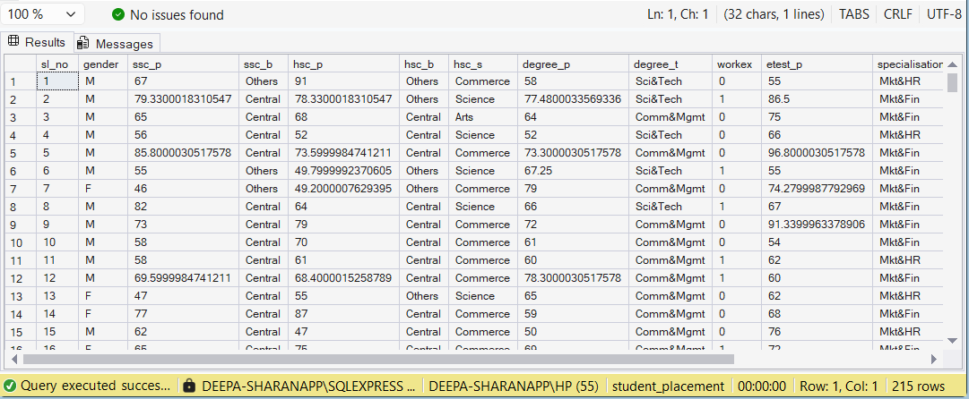

2. SELECT COUNT(*) AS total_students FROM student_placement;
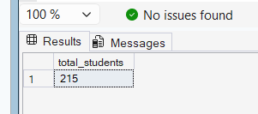

3. SELECT (COUNT(CASE WHEN status='Placed' THEN 1 END) * 100.0 / COUNT(*))
AS placement_percentage FROM student_placement;
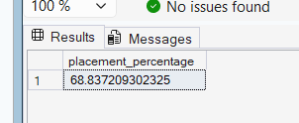

4. SELECT AVG(salary) AS avg_salary FROM student_placement
WHERE status = 'Placed';

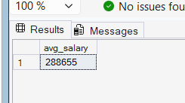

5. SELECT MAX(salary) AS highest_salary FROM student_placement;
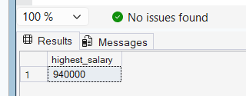

6. SELECT gender, COUNT(*) AS total FROM student_placement WHERE status = 'Placed'
GROUP BY gender;
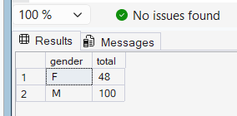

7. SELECT specialisation, COUNT(*) AS total FROM student_placement
WHERE status = 'Placed' GROUP BY specialisation;
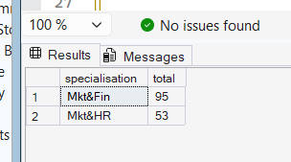

8. SELECT workex, COUNT(*) AS total FROM student_placement
WHERE status = 'Placed' GROUP BY workex;
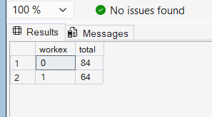

9. SELECT TOP 5 * FROM student_placement ORDER BY salary DESC;
